Langchain Project

- Download Google Antigravity IDE, set that up in your pc
- Create folder of project & open in IDE
- You’ll have to create virtual environment for that download uv package manager (An extremely fast Python package and project manager, written in Rust.)
- In IDE run this uv command - powershell -ExecutionPolicy ByPass -c "irm https://astral.sh/uv/install.ps1 | iex"
- Initiaze work space with command - uv init
- To create virtual environment - uv venv
- To activate vitual environment - .venv\Scripts\activate
- Create requirement.txt - To add all required packages/libraries - langchain, langgraph, langchain-openai, etc
- Then in cmd run this command - uv add -r requirements.txt which will install all libraries, after installation you can check in .toml file which version of it installed
- We need to integrate API key so I’m using free one - Gemini API, created new folder in root project .env filename & added API key
- In root project, create another folder generativeai -> new folder 1-langchainintro.ipynb
- Then to integrate an model you need to write like this
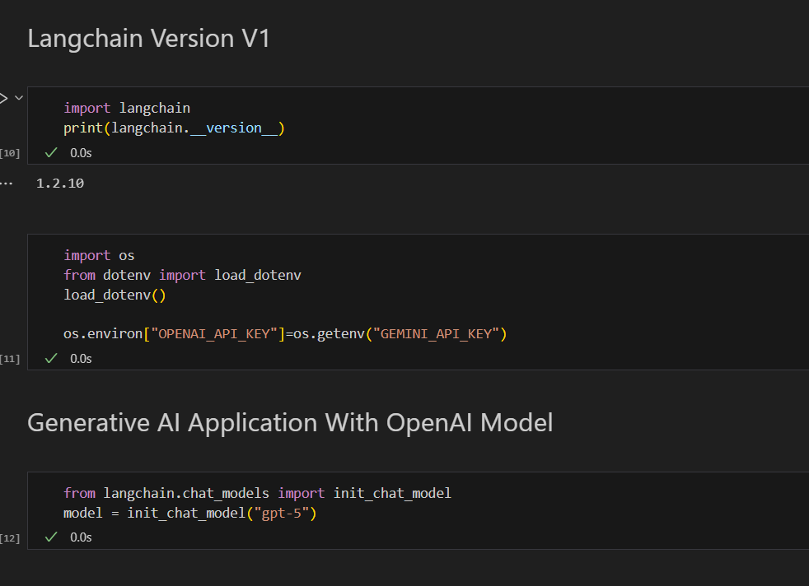
Example - LLM Model Integration with Google Gemini
